TRANSMITTAL OF SUBMITTAL
Date: 8/16/23
TO: Scott Miller  CMG – City of Atlanta  2528 Chattahoochee Circle  Atlanta, GA 30318  FROM: LAKESHORE ENGINEERING  1259 Ellsworth Drive  Atlanta, GA 30318 | New Submittal X Resubmittal  Project: East Area Water Quality Control Facility Improvements  Specification Section No. : 11358  Supplier/Vendor/Subcontractor: Eco Tech  Manufacturer: USGI Chemical Feed
The following items are hereby submitted:
Number of  Copies | Description of Item Submitted  (Type, Size, Model Number, Etc.) | Submittal number | Submittal Type | Contains Variation  to Contract
 |  |  |  | No | Yes
Email | – O&M Manual | 11358-70.01 | O&M Manual | X
Comments/Variation:
CONTRACTOR hereby certifies that (i) CONTRACTOR has complied with the requirements of Contract Documents in preparation, review, and submission of designated Submittal and (ii) the Submittal is complete and in accordance with the Contract Documents and requirements of laws and regulations and governing agencies.
By:____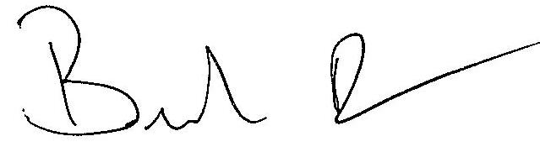_______________________________
Brandon Dow

