Subject: Flint River Pump Station – Bid Phase Questions / Answers
Date: 1/20/2026
Project Name: Flint River Pump Station Upgrade
Project Number: 30049010 Arcadis / XYZ Atlanta DWM
Client PM: Christina Clay (City of Atlanta Department of Watershed Management).
Account Lead: Michael Diaz, MS PE / Project Technical Lead: Travis Thomas, PE
- Received 12/19/2025 Our pipe supply has asked us for clarification on the below. Please see screen shots below from sheet M5-04. On all the pumps they show a 14x12 or 10x12 reducing elbow but that conflicts with the other details. I believe this is a typo and should just be 14” and 10” 90’s but wanted to confirm with you.
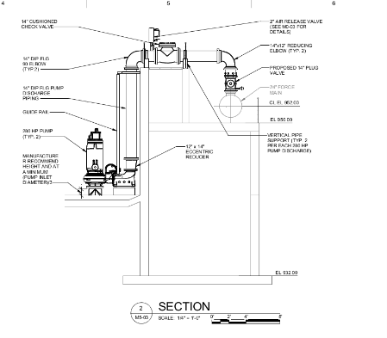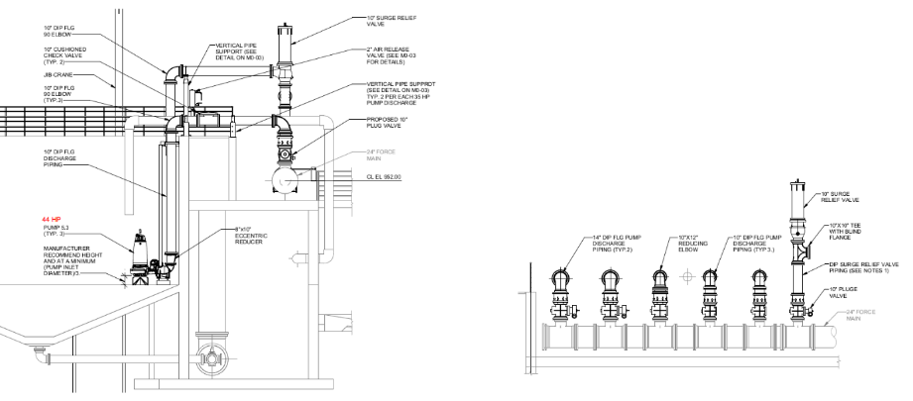
ANSWER: See marked drawings M5-03 and M5-04 emailed on 1/6/2026.
- Received 1/9/2026 Painting section 09900 is a copy from another job. Painting scope is for all new surfaces is standard. Repainting existing surfaces just what is damaged during this improvements or repaint all surfaces?
ANSWER: Refer to Specification 09900 Paragraph 3.7 for items to be painted and not requiring painting.
- Received 1/9/2026 On drawing S4-03 it mentions to coat all submerged concrete. Understand rehab material of concrete in section 03030.
a. Where is coating material mention in specs?
b. Is only the surfaces of the Screening Building to be coated.
ANSWER: Refer to Specification Section 09900 Paragraph 3.7 Painting Schedule Paint Material / Schedule 132 for a coating product that is acceptable. Per Sheet S4-03, coat all submerged concrete surfaces in the Screening Building only.

- Received 1/9/2026 Updated 1/13/2026 Section 15262, Article 2.3.A calls for 316SS discs, however Article 2.3.C states the Slide (disc) shall have an internal matrix of carbon steel of suitable strength for the specified service…..The plastic material shall be an Aramid fiber from the Kevlar family of fibers…..FRP, GRP, plastic coated or externally reinforced slide (disc) shall not be acceptable.” Please confirm the slide gate discs are to be 316 SS.
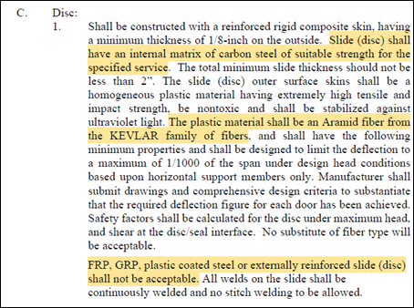
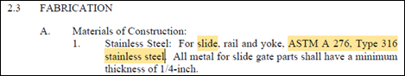
The gate is called out as 36 x 36 but designed head pressure states gate should hold back 5’ according to the schedule and 6.5’ according to the specs? As there is no hole to seal, the door will either need to be 5’ tall or 6.5’ tall (actually 73.92”, from invert to toc) to hold back head if this is really the case? Please confirm actual water level to hold back.
If the door is to be taller than 36”, either 60” or 73.92”, then it needs to be noted that the door will go above the concrete and put operator at either 56” or 84” above top of concrete. Is that allowable or do we need to make miter to bring operator down to 36”?
ANSWER: Provide 36” W x 60” H Embedded Channel Upward Opening Gate. Actuator will be approximately 42” tall. Slide gates to be 316SS. Fabricate the slide or disc of ASTM A 276, Type 316 stainless steel plate reinforced with structural shapes attached by welding. Provide reinforcing to limit deflection under full head to not more than 1/360 of the span. Extend reinforcing ribs into the guides overlapping the seating surface of the guide. Weld stem mounting guides to the disc to be replaced.
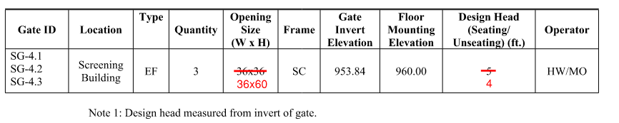
- On the existing door is a 6’x7’ with a transom above. We would like to propose removing the transom and providing a 6’x10’ in lieu of replacing the original door and having to infill above the door with masonry.
ANSWER: Replace all the windows at the Electrical Building. Replace the exterior double doors at the Electrical Building. Proposed change is rejected. Replace door and transom in kind.
- Received 1/9/2026 Please provide details/DWGS on the following:
- Depths of the 42” ductile iron influent line
- South River force main- unknowns; size, depth etc
- Current 12” above grade discharge point
ANSWER: See below.
a) Refer to Drawing M1-05 Section 3/M1-04 for centerline elevation.
b) Refer to Sheet C0-02 for existing 18” bypass pumping connection onsite. The force main is shown on the “Three Rivers Water Quality Management Plan Northern Part of Task No. 8 – Flint River WPCP Transmission Main” drawings dated 7-25-83. Drawing 8-C-1 shows the overall alignment of the 24” force main. Drawing 8-C-26 shows the alignment and profile of the force main near the Influent Pump Station. The force main generally has 4-ft of cover.
c) Not available. See above.
- Received 1/9/2026 Clarification on both temporary & construction bypass
ANSWER: Both will be required. Temporary bypass during the World Cup games scheduled for Atlanta between June 15 Group Stage and July 15 Semifinal. AND also, construction bypass as specified in 01014 Work Sequence and 02600 Wastewater Flow Control.

- Received 1/13/2026 Sheet E0-05 of the plan documents show a note for the Danfoss VLT Aqua Drive in a standard NEMA 1, fused disconnect configuration. The Spec section indicates that a custom enclosure drive is required with control power transformers and other equipment that will require a custom enclosure. Is the intent to meet the plans with the NEMA 12 fused disconnect with ethernet/IP to fit the proposed mounting location for the 11 VFD’s?
ANSWER: Yes but it is 9 VFDs. As a design package the drawings indicate the required enclosure NEMA rating according to the area of installation. Refer to Sheets E0-01, E0-05, E0-06 and the specifications for enclosure requirements, including the specified “optional” main disconnect. If an equipment supplier identifies the enclosure as “custom” per their delivery that does not modify or reduce the specification requirements. Refer to 16515 part 2.2 C, as well as 2.7 A1.
- Received 1/13/2026 Section 2.7, 1. C. of Spec section16515, lists active arc flash relays and light sensors, does that need to be included with the VFD or supplied by others?
ANSWER: Included with the VFDs. Refer to 16515 part 2.2 C and 2.7 A1 – (Factory assembled) and 2.7 A.1.c (in each drive). As a factory assembled drive the relays and sensors need to be provided with the VFD.
- Received 1/13/2026 Section 2.7, 1. F. indicates the drives will be integrated into an exterior wall or E-house, the plans do not agree with this, will the drives be mounted through a wall and require back-channel cooling?
ANSWER: No. Delete paragraph 16515 part 2.7 A 1 (f). Drives mounted inside the Electrical Room shown on E02-02 will be rack mounted per E02-02 note 1 and installation will not penetrate the wall of the Electrical Room. The specified cooling requirement for each drive is retained while surface mounted.

- Received 1/13/2026 Spec Section 11539 2.1.B calls for pumps 1.5-1.6 to have a 10” discharge. Sheet M1-05 shows a 12” x 10” reducer after the pump, indicating the discharge of the pump is 12”.
ANSWER: Pumps 1.5-1.6 have a discharge diameter of 12-inches.

- Received 1/13/2026 Are there any parallel operating conditions that can be provided to ensure our pumps meet the design intent?
ANSWER: No.

- Received 1/13/2026 Spec Section 11539 2.3.G.8 calls out for motor cooling jackets. We will be providing non-cooling jacketed pumps. Will this be accepted?
ANSWER: No, pumps will be provided with glycol cooled motors.

- Received 1/13/2026 Spec Section 11539 2.3.C lists impeller material to be high chrome cast iron. This is not an option on the pumps we are offering. Impellers will be cast iron A48-CL30. Will this be accepted?
ANSWER: No, impellers will be Hi-Chrome ASTM 532 Class IIIA Cast Iron.
- Received 1/13/2026 Who is the ICMSS? Is that referring to us?
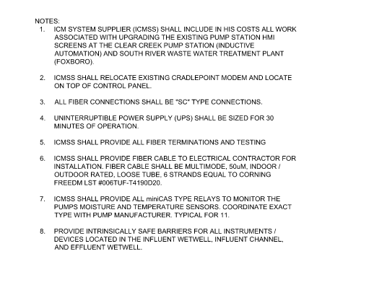
ANSWER: Refer to Specification 17000. The Contractor shall procure the services of a single ICM System Supplier (Supplier).
- Received 1/13/2026 If we are NOT the ICMSS, it seems the ICMSS will be doing the termination and testing per note 5, and the ICMSS will also be providing the fiber itself to the EC.
ANSWER: Refer to Specification 17000 Paragraph 1.1A.
- Received 1/13/2026 Are we to provide the CAT6A from the switches to the VFDs as shown on I-03 line diagrams? Or are they existing? If they are not existing, what kind of connectivity do we need to support the cabling?
ANSWER: Contractor to provide CAT6A ethernet cable inside conduit per Sheet E0-07 and Specification 16121.
- Received 1/13/2026 Lastly, is to move the security rack, what is in it, and will the existing cabling be long enough to reach the new destination? If not, how many cables are existing and what type(cat6/cat6a)?
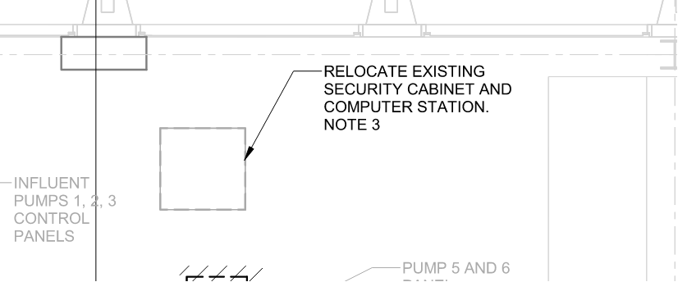
ANSWER: Contractor to field verify. Splice and extend as needed to new location shown on Sheet E2-02.
- Received 1/13/2026 Is this BABA project?
ANSWER:
- Received 1/14/2026 There is some discrepancy regarding the slide gate specifications and vendors have asked if the gates should be 316 stainless steel or Co-Plastix gates. Section 15262, Article 2.3.A calls for 316SS discs, however Article 2.3.C states the Slide (disc) shall have an internal matrix of carbon steel of suitable strength for the specified service…..The plastic material shall be an Aramid fiber from the Kevlar family of fibers…..FRP, GRP, plastic coated or externally reinforced slide (disc) shall not be acceptable.” In paragraph 1.3.C a 10-year guaranty is required as well, which is an Alfa Laval Co-Plastix Gate guaranty that the other listed manufacturers can’t provide. Please confirm that these gates should be Alfa-Laval Co-Plastix gates and not 316 SS. There are also some questions about the sizes of the gates as well. Can you answer these questions?
  - The gate is called out as 36 x 36 but designed head pressure states gate should hold back 5’ according to the schedule and 6.5’ according to the specs? As there is no hole to seal, the door will either need to be 5’ tall or 6.5’ tall (actually 73.92”, from invert to toc) to hold back head if this is really the case? Please confirm actual water level to hold back.
  - If the door is to be taller than 36”, either 60” or 73.92”, then it needs to be noted that the door will go above the concrete and put the operator at either 56” or 84” above top of concrete. Is that allowable or do we need to make miter to bring operator down to 36”?
ANSWER: See earlier response to a similar above.

